Isosceles Acute Triangle
# Source: AI Source: Provided by: [Data Path: Persons Table -> ID Column: 1, Name_En Column: Motasem Essam] -> From: [ChatGPT] on [7/25/2026]
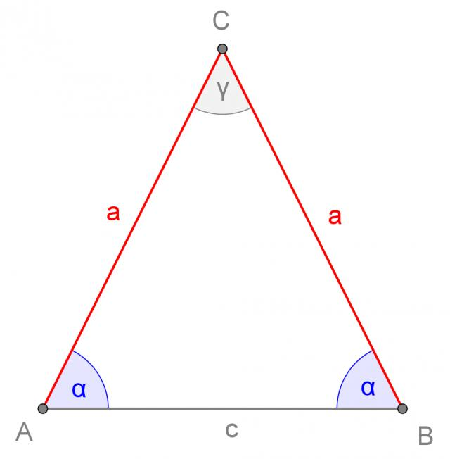
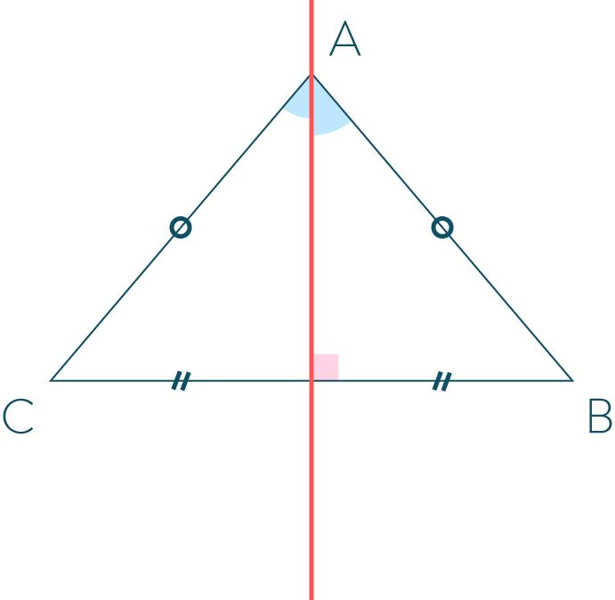
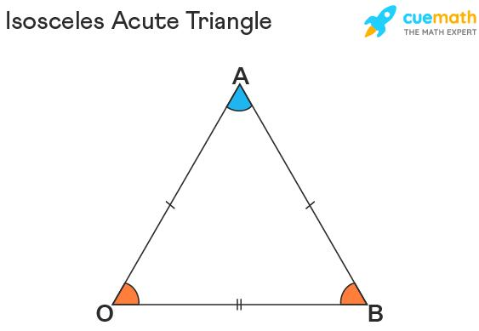
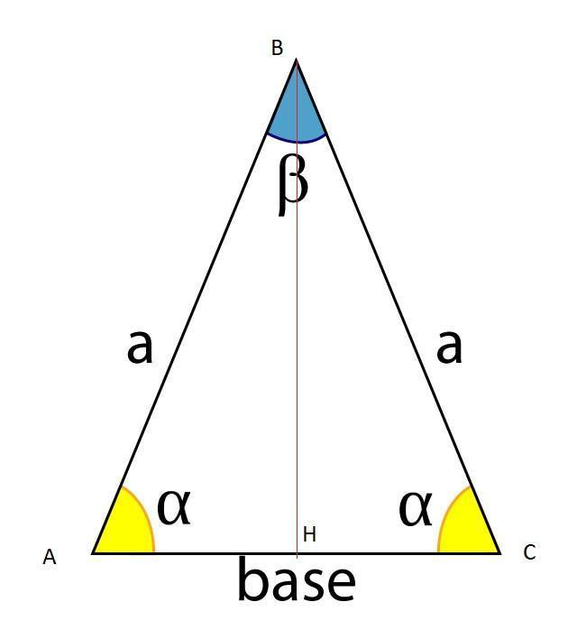
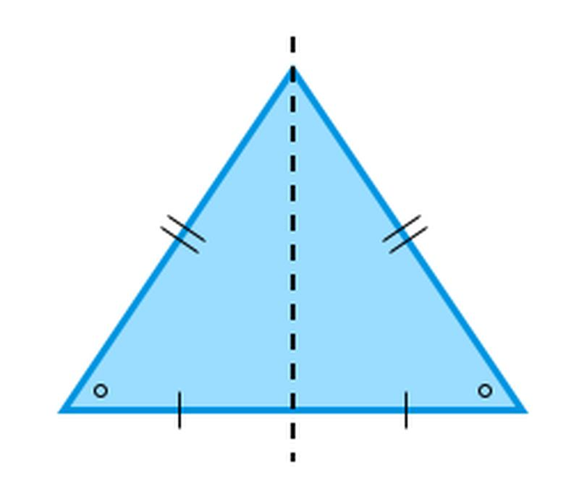

Definition
# Source: AI Source: Provided by: [Data Path: Persons Table -> ID Column: 1, Name_En Column: Motasem Essam] -> From: [ChatGPT] on [7/25/2026]
An Isosceles Acute Triangle is a triangle classified simultaneously:
- By sides: Isosceles — at least two sides are equal.
- By angles: Acute — all three interior angles are less than ${90}^{∘}$.
For triangle $ABC$, suppose:
$$\boxed{AB=AC}$$
Then the opposite base angles are equal:
$$\boxed{∠B=∠C}$$
For the triangle to be acute:
$$\boxed{∠A<{90}^{∘}, ∠B<{90}^{∘}, ∠C<{90}^{∘}}$$

Classification
# Source: AI Source: Provided by: [Data Path: Persons Table -> ID Column: 1, Name_En Column: Motasem Essam] -> From: [ChatGPT] on [7/25/2026]
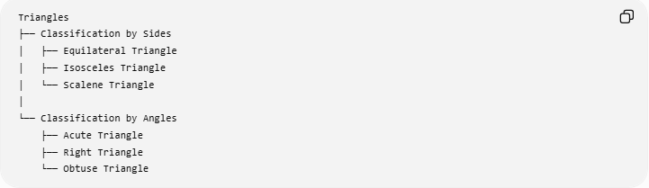
Triangles
├── Classification by Sides
│ ├── Equilateral Triangle
│ ├── Isosceles Triangle
│ └── Scalene Triangle
│
└── Classification by Angles
├── Acute Triangle
├── Right Triangle
└── Obtuse Triangle
The combined classification is:
Classification by Sides and Angles
└── Isosceles Acute Triangle
More specifically:
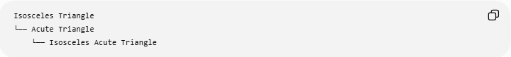
Isosceles Triangle
└── Acute Triangle
└── Isosceles Acute Triangle
Note: Under the broad mathematical definition, an equilateral triangle is also isosceles because it has at least two equal sides. If your knowledge base treats equilateral and isosceles as separate categories, then "Isosceles Acute" normally means the non-equilateral case with exactly two equal sides.

Fundamental Properties

1. Two Equal Sides
# Source: AI Source: Provided by: [Data Path: Persons Table -> ID Column: 1, Name_En Column: Motasem Essam] -> From: [ChatGPT] on [7/25/2026]
If:
$$\boxed{AB=AC=a}$$
then $AB$and $AC$are the equal sides, or legs.
The remaining side $BC$is the base:
$$\boxed{BC=b}$$

2. Two Equal Angles
# Source: AI Source: Provided by: [Data Path: Persons Table -> ID Column: 1, Name_En Column: Motasem Essam] -> From: [ChatGPT] on [7/25/2026]
The angles opposite the equal sides are equal:
$$\boxed{∠B=∠C}$$
These are called the base angles.

3. All Three Angles Are Acute
# Source: AI Source: Provided by: [Data Path: Persons Table -> ID Column: 1, Name_En Column: Motasem Essam] -> From: [ChatGPT] on [7/25/2026]
Because the triangle is acute:
$$\boxed{∠A<{90}^{∘}}$$
and:
$$\boxed{∠B<{90}^{∘}, ∠C<{90}^{∘}}$$
Therefore:
$$\boxed{0^{∘}<∠A,∠B,∠C<{90}^{∘}}$$

Angle Relationships
# Source: AI Source: Provided by: [Data Path: Persons Table -> ID Column: 1, Name_En Column: Motasem Essam] -> From: [ChatGPT] on [7/25/2026]
Because:
$$∠A+∠B+∠C={180}^{∘}$$
and:
$$∠B=∠C$$
we can write:
$$\boxed{∠B=∠C=\frac{{180}^{∘}-∠A}{2}}$$
For the triangle to remain acute, the vertex angle must satisfy:
$$\boxed{0^{∘}<∠A<{90}^{∘}}$$
The two base angles then satisfy:
$$\boxed{{45}^{∘}<∠B=∠C<{90}^{∘}}$$

Symmetry
A non-equilateral isosceles acute triangle has one line of reflection symmetry.
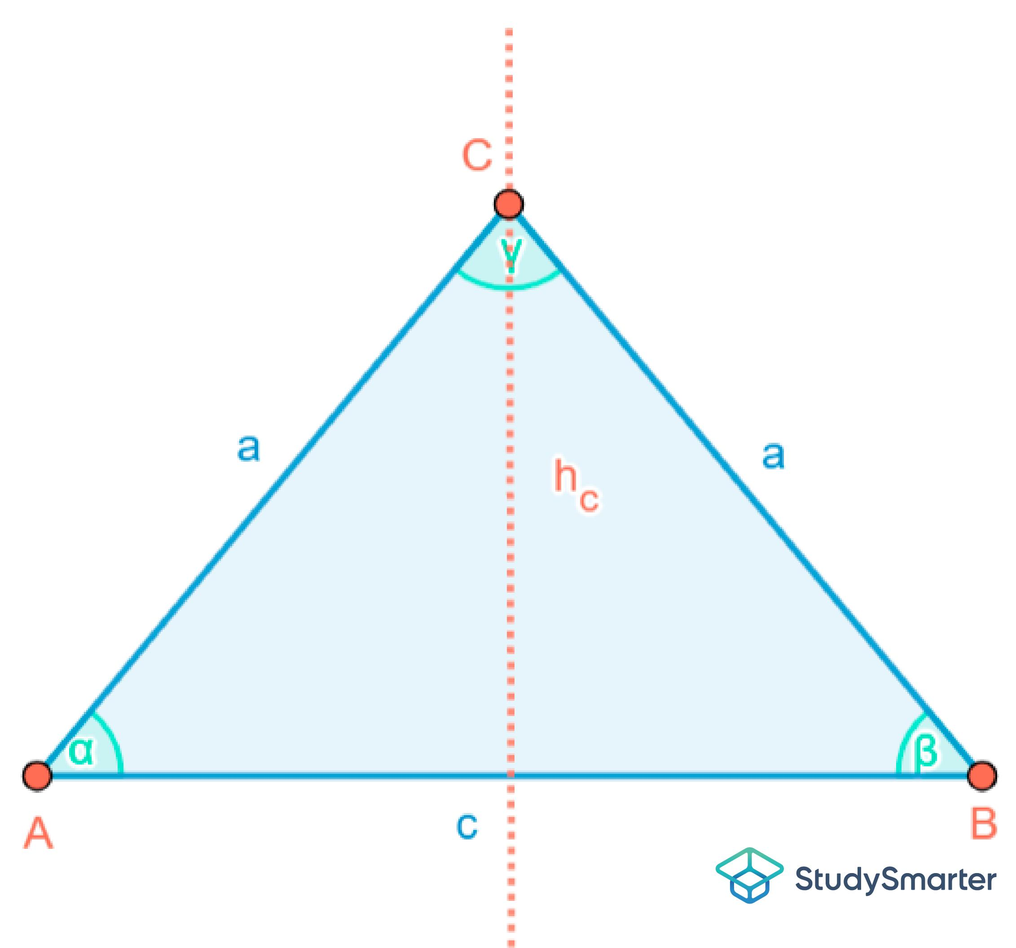
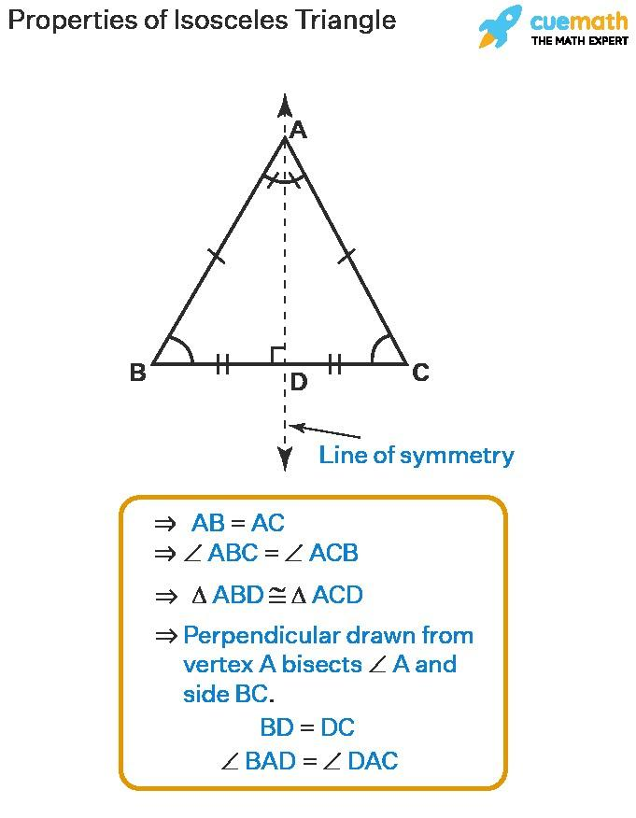
The symmetry axis passes through:
- The vertex between the equal sides
- The midpoint of the base
This segment is simultaneously:
$$\boxed{\text{Median}} \\ \boxed{\text{Altitude}} \\ \boxed{\text{Angle Bisector}} \\ \boxed{\text{Perpendicular Bisector of the Base}}$$

Altitude, Median, and Angle Bisector
# Source: AI Source: Provided by: [Data Path: Persons Table -> ID Column: 1, Name_En Column: Motasem Essam] -> From: [ChatGPT] on [7/25/2026]
Let $D$be the midpoint of base $BC$.
Then:
$$\boxed{BD=DC}$$
and:
$$\boxed{AD⊥BC}$$
Also:
$$\boxed{∠BAD=∠DAC}$$
Therefore, $AD$is simultaneously:
$$\boxed{\text{Median}=\text{Altitude}=\text{Angle Bisector}}$$
This is one of the defining geometric properties of an isosceles triangle.

Height
# Source: AI Source: Provided by: [Data Path: Persons Table -> ID Column: 1, Name_En Column: Motasem Essam] -> From: [ChatGPT] on [7/25/2026]
If the equal sides have length $a$and the base has length $b$, the altitude is:
$$\boxed{h=\sqrt{a^{2}-\frac{b^{2}}{4}}}$$
This follows by dividing the triangle into two congruent right triangles.

Area
# Source: AI Source: Provided by: [Data Path: Persons Table -> ID Column: 1, Name_En Column: Motasem Essam] -> From: [ChatGPT] on [7/25/2026]
Using the base and altitude:
$$\boxed{A=\frac{1}{2}bh}$$
Substituting the height formula:
$$\boxed{A=\frac{b}{2}\sqrt{a^{2}-\frac{b^{2}}{4}}}$$

Perimeter
# Source: AI Source: Provided by: [Data Path: Persons Table -> ID Column: 1, Name_En Column: Motasem Essam] -> From: [ChatGPT] on [7/25/2026]
If the equal sides are $a$and the base is $b$:
$$\boxed{P=2a+b}$$

Triangle Centers
# Source: AI Source: Provided by: [Data Path: Persons Table -> ID Column: 1, Name_En Column: Motasem Essam] -> From: [ChatGPT] on [7/25/2026]
In an isosceles acute triangle, the major triangle centers lie on the axis of symmetry.
These include:
- Centroid $G$
- Incenter $I$
- Circumcenter $O$
- Orthocenter $H$
Therefore:
$$\boxed{G, I, O, H\text{ lie on the symmetry axis}}$$
For a non-equilateral isosceles triangle, these centers are generally distinct.
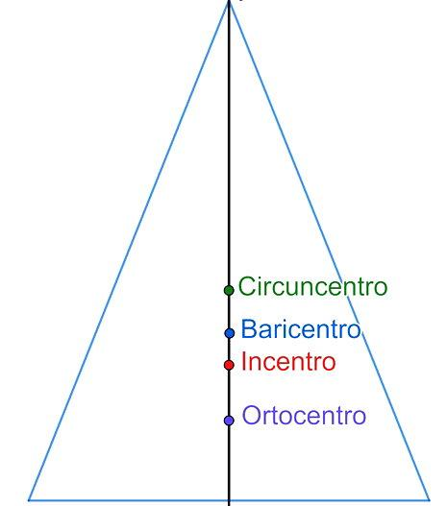
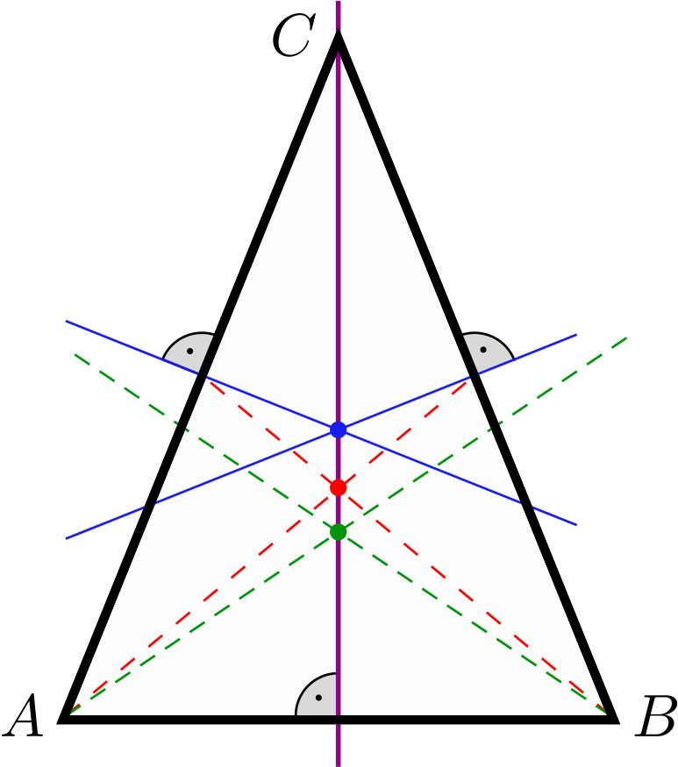
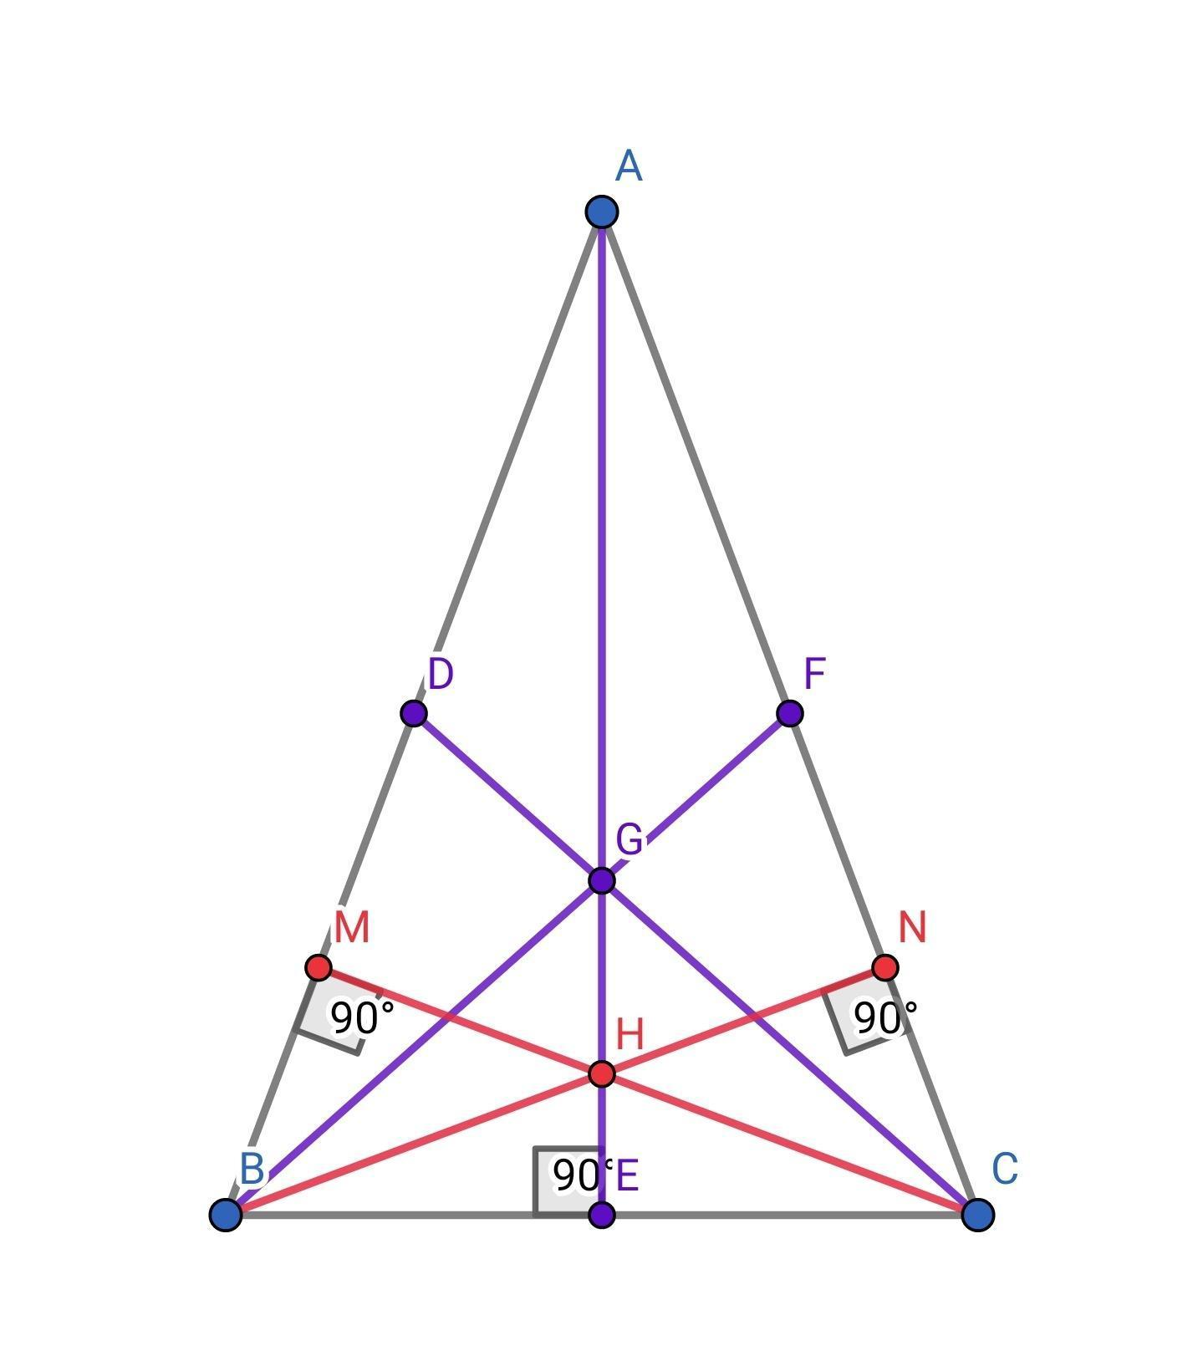
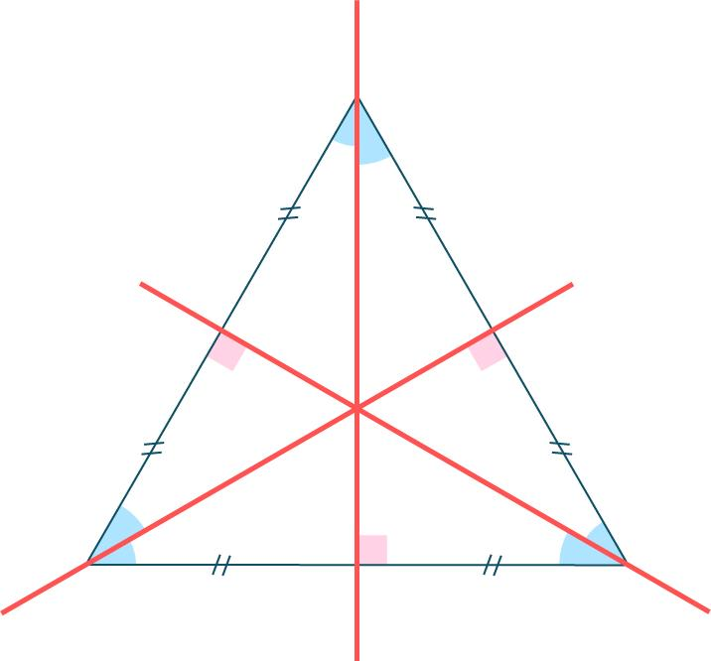
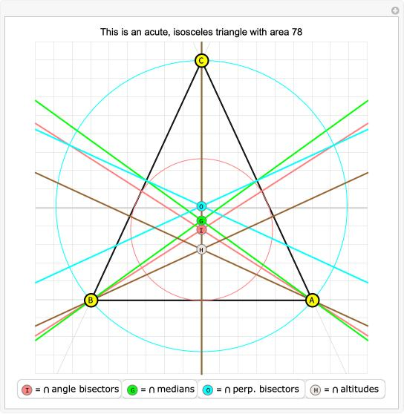

Orthocenter
# Source: AI Source: Provided by: [Data Path: Persons Table -> ID Column: 1, Name_En Column: Motasem Essam] -> From: [ChatGPT] on [7/25/2026]
Because the triangle is acute, its orthocenter lies inside the triangle:
$$\boxed{H\text{ is inside the triangle}}$$
The altitude from the vertex between the equal sides lies along the symmetry axis.

Circumcenter
# Source: AI Source: Provided by: [Data Path: Persons Table -> ID Column: 1, Name_En Column: Motasem Essam] -> From: [ChatGPT] on [7/25/2026]
Because the triangle is acute, its circumcenter also lies inside the triangle:
$$\boxed{O\text{ is inside the triangle}}$$
It lies on the perpendicular bisector of the base, which is the same as the symmetry axis.

Euler Line
# Source: AI Source: Provided by: [Data Path: Persons Table -> ID Column: 1, Name_En Column: Motasem Essam] -> From: [ChatGPT] on [7/25/2026]
For a non-equilateral isosceles acute triangle:
$$\boxed{O, G, H\text{ are collinear}}$$
The Euler line coincides with the triangle's symmetry axis.
The standard Euler-line relationship is:
$$\boxed{OG:GH=1:2}$$
or:
$$\boxed{OH=3OG}$$

Example
# Source: AI Source: Provided by: [Data Path: Persons Table -> ID Column: 1, Name_En Column: Motasem Essam] -> From: [ChatGPT] on [7/25/2026]
Consider an isosceles acute triangle with:
$$AB=AC=5$$
and:
$$BC=6$$
Height
The altitude divides the base into two segments of length $3$:
$$BD=DC=3$$
Using the Pythagorean theorem:
$$h^{2}+3^{2}=5^{2} \\ h^{2}=25-9=16 \\ \boxed{h=4}$$
Area
$$A=\frac{1}{2}\left(6\right)\left(4\right) \\ \boxed{A=12}$$
Perimeter
$$P=5+5+6 \\ \boxed{P=16}$$
Angles
Using the Law of Cosines for the vertex angle:
$$\cos{A}=\frac{5^{2}+5^{2}-6^{2}}{2\left(5\right)\left(5\right)} \\ \cos{A}=\frac{14}{50}=0.28$$
so:
$$\boxed{∠A≈{73.74}^{∘}}$$
The base angles are equal:
$$∠B=∠C$$
and:
$$\boxed{∠B=∠C≈{53.13}^{∘}}$$
All three angles are less than ${90}^{∘}$, confirming that the triangle is acute.

Special Case: Equilateral Triangle
# Source: AI Source: Provided by: [Data Path: Persons Table -> ID Column: 1, Name_En Column: Motasem Essam] -> From: [ChatGPT] on [7/25/2026]
An equilateral triangle can be regarded as a special case of an isosceles triangle under the at-least-two-equal-sides definition.
However, if your classification uses exactly two equal sides for an isosceles triangle, then an equilateral triangle is excluded.
For the knowledge-base classification, keeping them as separate direct categories is clear:
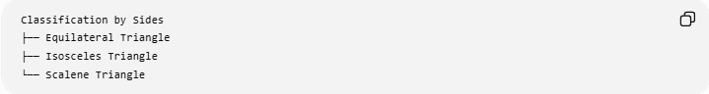
Classification by Sides
├── Equilateral Triangle
├── Isosceles Triangle
└── Scalene Triangle

Relationship with Other Combined Types
# Source: AI Source: Provided by: [Data Path: Persons Table -> ID Column: 1, Name_En Column: Motasem Essam] -> From: [ChatGPT] on [7/25/2026]
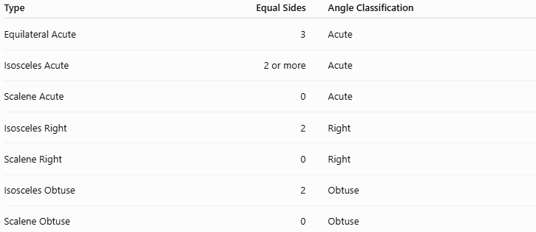
Type | Equal Sides | Angle Classification
Equilateral Acute | 3 | Acute
Isosceles Acute | 2 or more | Acute
Scalene Acute | 0 | Acute
Isosceles Right | 2 | Right
Scalene Right | 0 | Right
Isosceles Obtuse | 2 | Obtuse
Scalene Obtuse | 0 | Obtuse
Under the exactly-two-equal-sides convention, the three acute categories are:
$$\boxed{\text{Equilateral Acute}} \\ \boxed{\text{Isosceles Acute}} \\ \boxed{\text{Scalene Acute}}$$

Real-World Applications
# Source: AI Source: Provided by: [Data Path: Persons Table -> ID Column: 1, Name_En Column: Motasem Essam] -> From: [ChatGPT] on [7/25/2026]
Isosceles acute triangles appear in:
- Architectural designs
- Roof structures
- Trusses
- Decorative patterns
- Structural frameworks
- Mechanical components
- Computer graphics
- Geometric modeling
- Surveying
Their symmetry makes them particularly useful when a design requires equal side lengths and balanced geometry.

Comparison with Other Acute Triangles
# Source: AI Source: Provided by: [Data Path: Persons Table -> ID Column: 1, Name_En Column: Motasem Essam] -> From: [ChatGPT] on [7/25/2026]
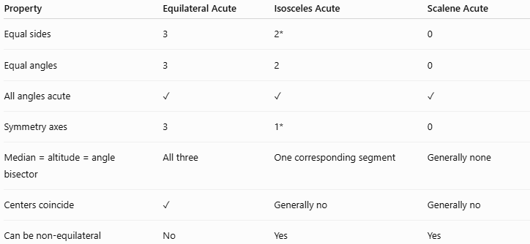
Property | Equilateral Acute | Isosceles Acute | Scalene Acute
Equal sides | 3 | 2* | 0
Equal angles | 3 | 2 | 0
All angles acute | ✓ | ✓ | ✓
Symmetry axes | 3 | 1* | 0
Median = altitude = angle bisector | All three | One corresponding segment | Generally none
Centers coincide | ✓ | Generally no | Generally no
Can be non-equilateral | No | Yes | Yes
*For the non-equilateral isosceles case.

Key Points
# Source: AI Source: Provided by: [Data Path: Persons Table -> ID Column: 1, Name_En Column: Motasem Essam] -> From: [ChatGPT] on [7/25/2026]
- An Isosceles Acute Triangle is both isosceles by sides and acute by angles.
- It has at least two equal sides:
$$\boxed{AB=AC}$$
- Its corresponding base angles are equal:
$$\boxed{∠B=∠C}$$
- All three angles are less than ${90}^{∘}$.
- The two base angles satisfy:
$$\boxed{∠B=∠C=\frac{{180}^{∘}-∠A}{2}}$$
- A non-equilateral isosceles triangle has one line of symmetry.
- The symmetry segment is simultaneously a median, altitude, angle bisector, and perpendicular bisector.
- The orthocenter and circumcenter lie inside because the triangle is acute.
- The centroid, incenter, circumcenter, and orthocenter all lie on the symmetry axis.
- For a non-equilateral isosceles triangle, the symmetry axis is also the Euler line.
- An isosceles acute triangle may be classified further by its exact side/angle measurements.

Conclusion
# Source: AI Source: Provided by: [Data Path: Persons Table -> ID Column: 1, Name_En Column: Motasem Essam] -> From: [ChatGPT] on [7/25/2026]
An Isosceles Acute Triangle combines two classifications: it has two or more equal sides and three acute angles. In the non-equilateral case, its symmetry produces one special axis on which the centroid, incenter, circumcenter, and orthocenter lie. Its vertex-to-base segment simultaneously acts as a median, altitude, angle bisector, and perpendicular bisector, making it an important symmetric configuration in plane geometry.

